1. In your Arduino IDE, go to ****File****> ****Preferences****

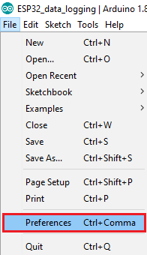

1. Enter the following into the “Additional Board Manager URLs” field:

https://raw.githubusercontent.com/espressif/arduino-esp32/gh-pages/package_esp32_index.json

Then, click the “OK” button:

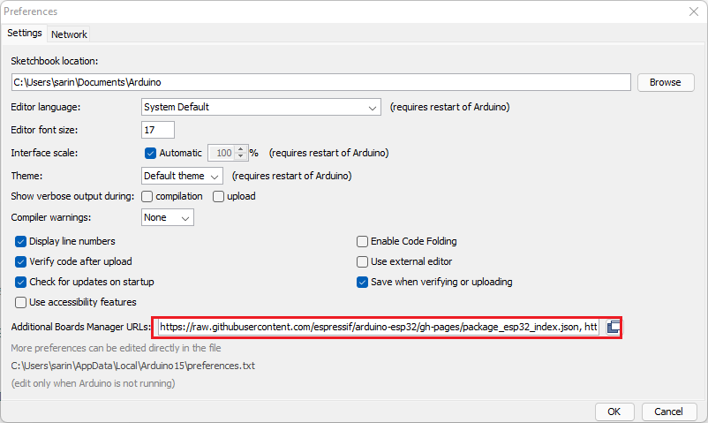

****Note:**** if you already have the ESP8266 boards URL, you can separate the URLs with a comma as follows:

https://raw.githubusercontent.com/espressif/arduino-esp32/gh-pages/package_esp32_index.json, <http://arduino.esp8266.com/stable/package_esp8266com_index.json>

1. Open the Boards Manager. Go to ****Tools**** > ****Board**** > ****Boards Manager…****

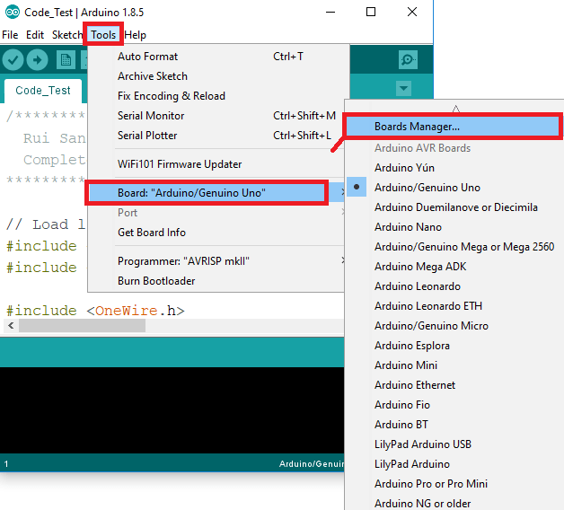

4-Search for ****ESP32**** and press install button for the “****ESP32 by Espressif Systems****“:

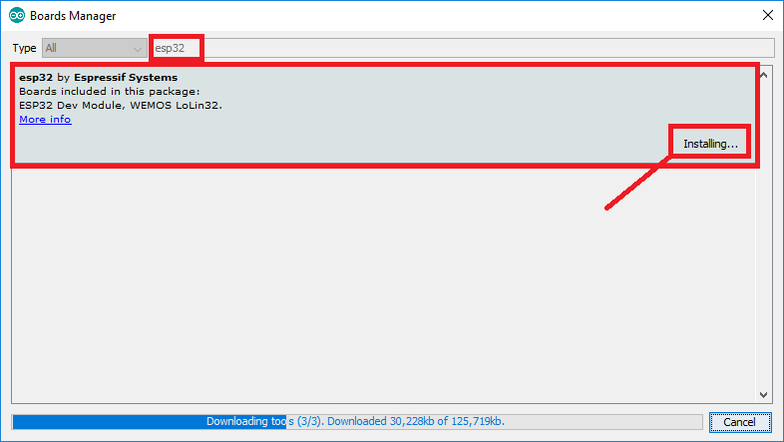

5-That’s it. It should be installed after a few seconds.

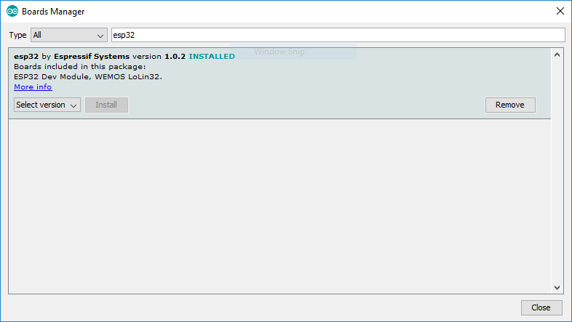

Code:

the setup function runs once when you press reset or power the boardvoid setup() {

// initialize digital pin ledPin as an output.

pinMode(ledPin, OUTPUT);}

// the loop function runs over and over again forevervoid loop() {

digitalWrite(ledPin, HIGH); // turn the LED on (HIGH is the voltage level)

delay(1000); // wait for a second

digitalWrite(ledPin, LOW); // turn the LED off by making the voltage LOW

delay(1000